Supporting Information for the Screening for Appropriate Assessment Report

CABLES – Capturing elAsmobranch Behaviour in eLEctromagnetic fieldS
Sustainability Institute, University College Cork

January 2026

Table of Contents
1. Introduction 2
1.1 Aim of report 3
1.2 Background 3
1.3 Statement of Authority 4
2. Methodology 4
2.1 Appropriate Assessment Guidance 4
2.2 Stages of Appropriate Assessment 5
2.3 Identification of Relevant European Sites 6
3. Description of the Proposed Project 6
3.1 Proposed Location 6
3.2 Design of deployment 7
3.3 Deployment Procedure and Maintenance Operations 7
3.4 Receiving Environment 7
4. Identification of relevant European Sites 7
4.1 Identification of Potential Sources of Impacts 8
4.2 Identified European sites 8
4.2.1 Connectivity with European Sites 10
5. Identification of potential environmental impacts 10
5.1 Management of Natura 2000 site/s 10
5.2 Identification of possible effects 10
5.3 Vessel Operations 11
5.4 Habitat Disturbance and Loss 11
5.5 Underwater Noise 11
5.6 Accidental spillage 12
5.7 Invasive Alien Species 13
5.8 In-combination and cumulative effects 13
Conclusion 15
References 15

1. Introduction

1.1 Aim of report
The purpose of this report is to inform the Appropriate Assessment process, as required under the Habitats Directive (92/43/EEC). The report assesses whether the proposed project, either alone or in-combination with other plans or projects, is likely to have significant effects on any European site(s). It will establish if a screening for an Appropriate Assessment, as described above, is required, thus meeting the Department’s statutory obligations under the European Communities (Birds and Natural Habitats) Regulations 2011 to 2021 (the “Habitats Regulations”), to ensure compliance with the Habitats Directive (92/43/EEC).

1.2 Background
The Irish government is committed to increasing Offshore Renewable Energy (ORE) capacity to 5 GW by 2030 (Climate Action Plan 2024). This ambition will include a dramatic scaling up of all infrastructure, including cables which emit electromagnetic fields (EMF) in the marine environment. Elasmobranchs (sharks, skates and rays) are uniquely sensitive to electromagnetic fields and possess the ability to detect relatively weak fields and are thus vulnerable to the proliferation of artificial EMF which may disrupt their natural foraging and communication behaviour. More than half of elasmobranch species in Irish waters are in decline and designated as vulnerable, endangered or critically endangered using IUCN criteria (Clarke et al., 2016). Elasmobranchs are an important part of our pelagic ecosystems and integral to ecosystem services and therefore, the sustainable development of the ORE sector is dependent on a better understanding of elasmobranch - EMF impacts.
A small number of studies have investigated interactions with electromagnetic fields from power transmission structures outside the laboratory revealing strong evidence of behavioural effects (Gill et al., 2009; Hutchison et al., 2020). But substantial knowledge gaps remain, and important questions include are elasmobranchs able to habituate to artificial EMF, are there long-term changes in behaviour (attractant or barrier effects) and, what are the energetic costs of these potential impacts. This project aims to address some of these knowledge gaps. The CABLES project is led by researchers from the University College Cork (UCC) and MaREI Centre and is a continuation of the Research Ireland funded Tintreach project which began in 2022. Core CABLES objectives are.
Obj 1. To examine the effect of EMF emitted from an HVDC cable on the 3D movement trajectories of 60 independently studied small-spotted catsharks (Scyliorhinus canicula) using exposure (N = 30) and controls (N = 30).
Obj 2. To investigate whether fluctuating EMF levels lead to changes in the movement rate of small-spotted catsharks, by using the paired acceleration data from the above experimental trials.
Obj 3. To obtain high-resolution EMF recordings using a custom-made static magnetometer unit, which can be used in subsequent movement modelling.

We will be using high residency acoustic telemetry positioning in the proposed location to identify elasmobranch movement and behaviors. Over the last decade, the development of animal tracking technology, including acoustic telemetry, has enabled the tracking of fully aquatic animals in their natural environment (Hussey et al. 2015; Orrell et al. 2022). Acoustic telemetry involves either externally attaching or internally implanting an acoustic transmitter (hereafter “tag”) on/into an animal. When a tagged animal comes within the detection range of an acoustic receiver the unique tag identifier and the time of detection are logged on the receiver. Acoustic receivers are passive acoustic devices or “microphones” that do not emit sound and only record tags operating over a specific frequency band. This technology has had further innovations to estimate two-dimensional (latitude, longitude) position and increase ping rate using high residency systems. High residency systems can detect animals every two seconds compared to every minute on standard systems. Two-dimensional positioning is achieved if an animal is detected on at least three receivers at the same time and using time differences between receivers. By combining these technologies, it is possible to track the position of tagged animals in short time intervals, giving detailed information on animal movements and behaviors.

This Supporting Information for Screening for Appropriate Assessment Report has been created to assess University College Cork’s proposed temporary deployments of two mesh enclosures, acoustic receivers, and lighted navigation buoys in Cork Harbour, Co. Cork. A Maritime Usage License Application for the project is submitted with this report. This report’s main goal is to provide information for the Appropriate Assessment (AA) process to help inform the decision-making process as to whether the proposed project, both by itself and in conjunction with other plans or projects, has the potential to have a significant impact on any designated European Site considering the site’s conservation goals.

1.3 Statement of Authority
This report was authored by Dr. Damien Haberlin, Dr Danielle Orrell and Alfonso Cohuo to support the CABLES project. The CABLES team includes Dr. Danielle Orrell (CABLES Principal Investigator), Dr. Damien Haberlin (Co- PI), Dr Tom Doyle (mentor) and Senior Technician Luke Harman who have successfully run several biotelemetry (tracking) studies in Irish waters of species including compass jellyfish (Chrysaora hysoscella), sea bass (Dicentrachus labrax) and blue shark (Prionace glauca). Dr. Danielle Orrell has a decade of animal tracking experience from tracking juvenile salmon smolts in Scottish lochs to tracking Galapagos sharks off the east coast of Africa. Dr Haberlin has over a decade of animal tracking experience and was principal investigator on the TINTREACH project, with CABLES building on that work. Alfonso Cohuo has conducted and analysed acoustic telemetry data for Gulf sturgeon (Acipenser oxyrinchus desotoi) tagged in Mississippi, USA.

2. Methodology

2.1 Appropriate Assessment Guidance
EU and national guidance exist in relation to Member States’ fulfilling their requirements under the EU Habitats Directive, with particular reference to Article 6(3) and 6(4) of that Directive. Appropriate Assessment is the process through which the possible nature conservation implications of any plan or project on the Natura 2000 site network is considered by a Competent Authority, before a decision is made to allow that plan or project to proceed. The methodology followed in relation to this AA has had regard to the following guidance:

- Appropriate Assessment Screening for Development Management OPR Practice Note PN01 March 2021
- Appropriate Assessment under Article 6 of the Habitats Directive: Guidance for Planning Authorities. Circular NPW 1/10 & PSSP 2/10.
- Appropriate Assessment of Plans and Projects in Ireland - Guidance for Planning Authorities. (Department of Environment, Heritage and Local Government, 2010).

The assessment in this report is based on the report Appropriate Assessment Screening for Development Management, OPR Practice Note PN01, published March 2021. The potential for substantial impacts on a European site is based upon the presence of a clear connection, known as the Source-Pathway-Receptor link, between the planned development and the European site, as outlined in OPR 2021. Therefore, we have assessed potential connectivity in two scenarios: 1) if there is an overlap between the Maritime usage license area and a European site, and 2), if the European site fell within the range of the anticipated impacts of the proposed activity, indicating indirect effects. Also, to evaluate the potential for the project to have significant effects on European sites when combined with other existing, ongoing, or foreseeable future plans or projects, an assessment for screening for cumulative impacts was made, by evaluating the current and foreseeable licensed maritime activities in the area.

2.2 Stages of Appropriate Assessment

The European Commission’s methodological guidance (European Commission, 2002) promotes a four-stage process to complete the Appropriate Assessment. Each successive stage determines whether a further stage in the process is necessary. The four stages are the following:

Stage 1: Screening for Appropriate Assessment
In this initial stage, the focus is on evaluating and documenting the rationale and outcomes concerning Article 6(3). The primary objective is to ascertain whether a given plan or project has a direct association with or significant relevance to the management of a specific site. Additionally, this stage aims to determine if a project, either on its own or when combined with another project, holds the potential to cause adverse effects on European site(s).

Stage 2- Appropriate Assessment
In this stage, the assessment focuses on determining the project’s impact on the integrity of a European site(s) concerning its conservation objectives, structure, and function. Mitigation measures should be applied to ensure that no adverse effects on the site(s) remain.

Stage 3 - Alternative Solutions
In the event that the Appropriate Assessment indicates potential adverse impacts on European site(s), this stage explores alternative approaches to project implementation, aiming to avoid these adverse effects whenever feasible. It is important to note that Stage 3 is not considered as the primary reliance point.
Stage 4 - Imperative Reasons of Overriding Public Interest
When no alternative solutions are available and adverse impacts persist, an assessment is conducted to see if compensatory measures can offset the harm to the European site(s), considering imperative reasons of overriding public interest (IROPI). European law stresses the need to explore alternatives outside the project area during this assessment. However, the IROPI test is stringent, and most projects are unlikely to pass it. Furthermore, it is worth mentioning that the developer does not rely heavily on Stage 4.

This report will address stage 1 by describing the following:
- Determine whether a project is connected or necessary to the conservation management of any European site
- Describe the project
- Identify the European sites potentially impacted by the project using an SPR model.
- Identify and describe potential sources and effects of the project on European sites alone and in combination and cumulatively with other licensed activity.
- Assess the likelihood of significant impacts on European sites.

2.3 Identification of Relevant European Sites

Relevant European sites were identified using two criteria:
- All European sites within Cork Harbour were identified.
- European sites outside of the harbour were identified when they intersected with the “zone of influence” (ZOI) of the proposed location and related works using the Source-Pathway-Receptor (SPR) model defined in OPR 2021. The equipment and required vessels needed were reviewed to establish if a source/pathway existed and if so, what receptors might be impacted.

The ZOI was determined based on the scale and scope of project activities (sources), direct and indirect connectivity pathways and potential cumulative impacts for the project.

3. Description of the Proposed Project

3.1 Proposed Location
The proposed location is in the northeast portion of Cork Harbour, a large natural port fed mainly by the rivers Lee, Douglas, Owenabue, and Owenacurra (Figure 1). The harbour is largely composed of coarse soft sediments (Marine Institute, 2023). The proposed location satisfied four selection criteria preferred for this project, they are as follows:
- The presence of an existing power transmission cable.
- Relatively calm sheltered environment.
- An area of minimal vessel traffic.
- Shallow depths, not exceeding 6m during high spring tide.

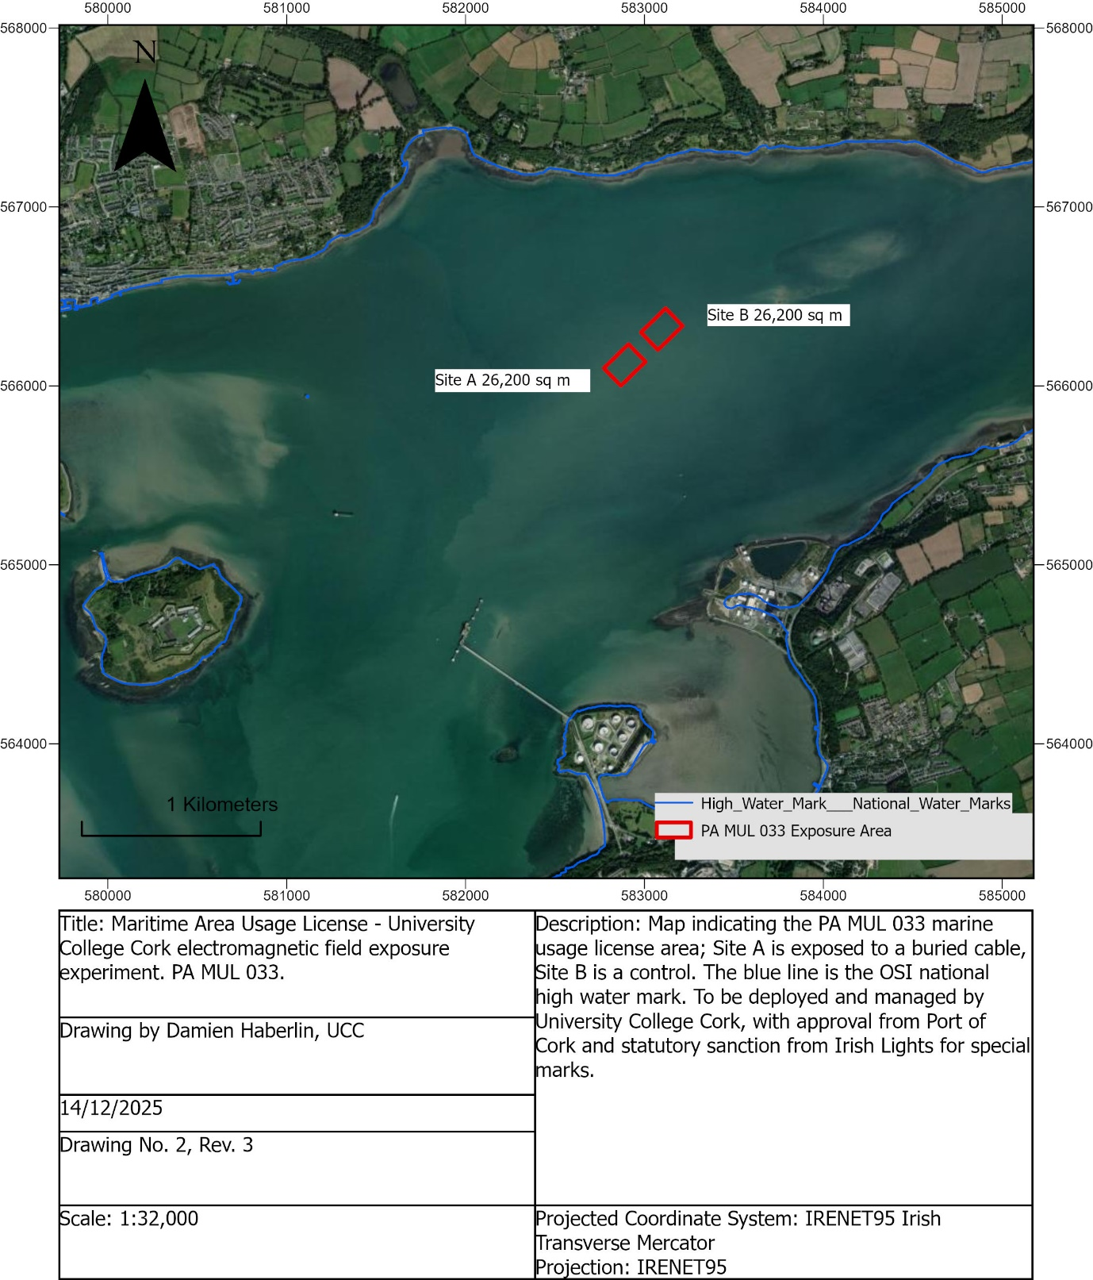

Figure 1. Map of the proposed location in Cork Harbour.

3.2 Design of deployment
The work in the proposed location requires deployment of 2 enclosures, each consisting of three pieces of equipment, the 40mm nylon mesh enclosure, the special mark buoys, and the acoustic receiver moorings.

The 40 mm nylon mesh enclosure, measuring 50 m x 15 m x 5 m, is enclosed on all sides with an open top lined with seine floats. Four 200 kg scrap chains will be connected by two sets of 12 mm diameter polysteel rope to moor the enclosure in place. The enclosure will be positioned on top of the cables as shown in Figure 2.

The special mark navigational buoys will be deployed close (<5 m) to each corner of the enclosure by splicing together 12 mm polysteel from the mooring lines described above (Figure 3).

Acoustic receiver moorings will be placed just outside the perimeter of the enclosure. They are composed of an ABS plastic tube embedded in an 80 kg concrete block. Figure 4 shows specific dimensions of the mooring.

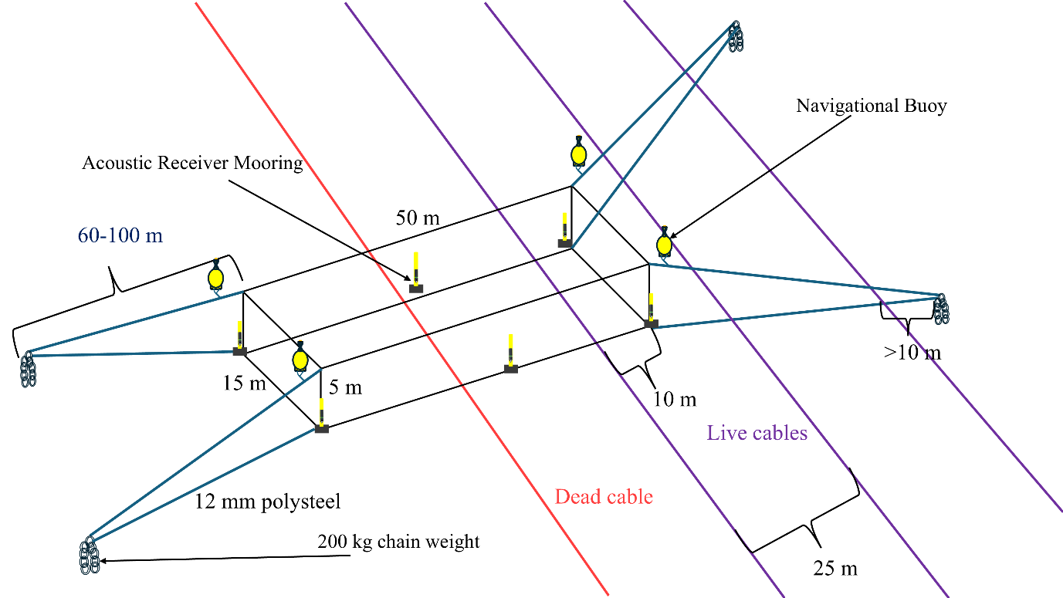
Figure 2. Overview of the enclosure, mooring system, acoustic receiver and navigational buoys in relation to buried power transmission cables.

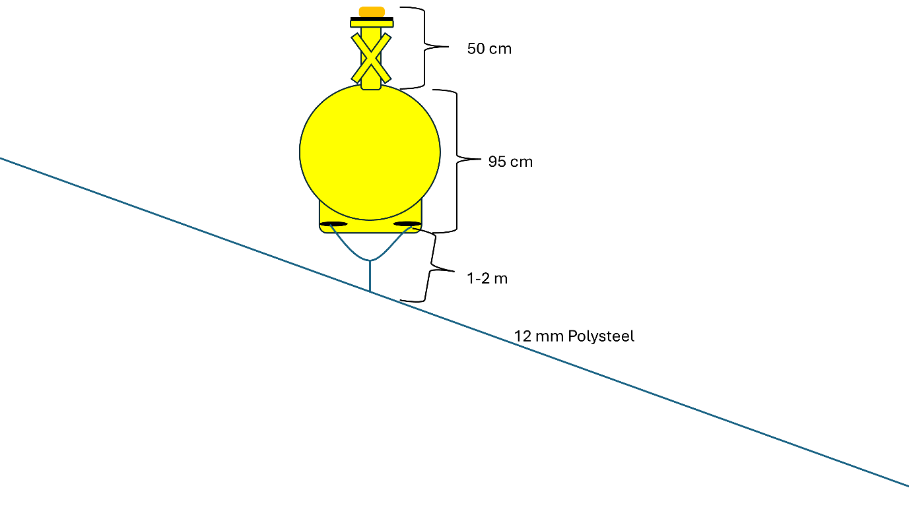
Figure 3. Dimensions and attachment of navigation buoys to mooring system lines.
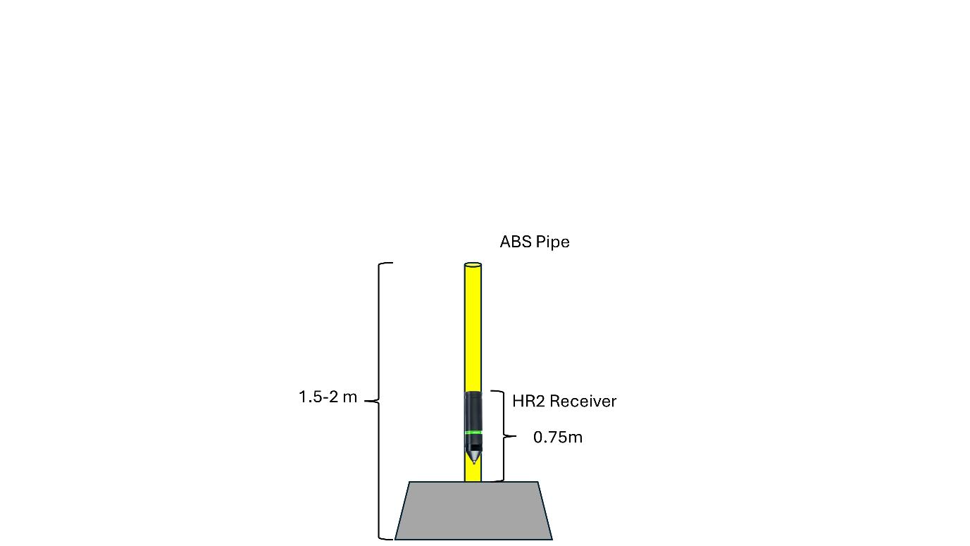
Figure 4. HR2 acoustic receiver moorings.

3.3 Deployment Procedure and Maintenance Operations
Equipment will be deployed and retrieved using a charter vessel with a HIAB crane and hauler while animal tagging/monitoring will be carried out using the UCC 7 m RIB. All equipment will be recovered after a maximum of 12 months. Retrieval is subject to weather conditions, licensing, and vessel availability. All equipment will be removed on the same day if possible.

3.4 Receiving Environment
Six HR2 acoustic receivers will be deployed surrounding the mesh enclosure. The seabed of the proposed location is composed of coarse soft sediments with a depth range of 2.5 m – 6 m depending on the tidal cycle. All receiver moorings will be composed of 1.5 -2 m of ABS plastic or PVC tube that will remain subsurface at low tides. Acoustic receivers will be attached to the tubes no more than 1 m above the seabed. A small surface float will be secured to the tube with 14mm polypropylene rope to quickly identify their position on the surface.

4. Identification of relevant European Sites

4.1 Identification of Potential Sources of Impacts
Identification of potential impacts from sources is related to activities and infrastructure deployed in the proposed location. A listed impact from a source is not guaranteed to occur, but there is some likelihood that it may occur. In addition, impacts will have different probability of occurring and may be considered in the conclusion of this report. If an impact does occur, it may result in ecological or environmental damage in or around the proposed location or it may significantly impact an identified European site. A list of potential sources from this project are found in Table 1.

Table 1. SPR model with accompanying activity and predicted impact area.
Activity | Source |  |  | Path | Receptor | Impact Area
Vessel Presence |  | Disturbance, injury, or harm | Water, Air |  | Marine mammals, fish, birds | Immediate vessel area
Vessel Presence |  | Accidental spillage of hydrocarbons | Water |  | Benthic habitats, marine mammals, birds, fish | NA (see section 5.6)
Vessel Presence |  | Introduction of Invasive alien species | Water |  | Benthic habitats, fish | NA (see section 5.7)
Enclosure Deployment |  | Entanglement, disturbance | Water |  | Marine mammals, fish, birds, benthic community, benthic habitat | Immediate enclosure area
Acoustic Receiver Operation |  | Disturbance because of underwater noise | Water |  | Marine mammals | Immediate acoustic receiver area (see section 5.5 for details)
Special mark navigational buoy deployment |  | Disturbance to seabed, Entanglement | Water |  | Benthic habitats, marine mammals, birds, fish | Immediate buoy and mooring area

4.2 Identified European sites.
The proposed location did not overlap with any European sites. The Cork Harbour SPA was identified based on its location in Cork Harbour. Based on the SPR model, one European Site was identified: the Roaringwater Bay and Islands SAC (Table 2).
Table 2. European sites and their qualifying interests to be considered further in the screening process.
European Site Name and Code |  | Distance (km) from Project |  | Qualifying/Special Conservation interest | Reason(s) for inclusion
Cork Harbour SPA [Site code 004030] | >3 km |  | [A004] Little Grebe (Tachybaptus ruficollis)  [A005] Great Crested Grebe (Podiceps cristatus)  [A017] Cormorant (Phalacrocorax carbo)  [A028] Grey Heron (Ardea cinerea)  [A048] Shelduck (Tadorna tadorna)  [A052] Teal (Anas crecca)  [A054] Pintail (Anas acuta)  [A069] Red-breasted Merganser (Mergus serrator)  [A130] Oystercatcher (Haematopus ostralegus)  [A140] Golden Plover (Pluvialis apricaria)  [A141] Grey Plover (Pluvialis squatarola)  [A142] Lapwing (Vanellus vanellus)  [A149] Dunlin (Calidris alpina)  [A156] Black-tailed Godwit (Limosa limosa)  [A157] Bar-tailed Godwit (Limosa lapponica)  [A160] Curlew (Numenius arquata)  [A162] Redshank (Tringa totanus)  [A179] Black-headed Gull (Chroicocephalus ridibundus)  [A182] Common Gull (Larus canus)  [A183] Lesser Black-backed Gull (Larus fuscus)  [A193] Common Tern (Sterna hirundo)  [A855] Wigeon (Mareca penelope)  [A857] Shoveler (Spatula clypeata)  [A999] Wetland and Waterbirds |  | Located in Cork Harbour.
Roaringwater Bay and Islands SAC [Site code 000101] | >85 km |  | [1160] Large shallow inlets and bays  [1170] Reefs  [1230] Vegetated Sea cliffs of the Atlantic and Baltic coasts  [4030] European dry heaths  [8330] Submerged or partially submerged sea caves  [1355] Otter (Lutra lutra)  [1364] Grey seal (Halichoerus grypus)  [1351] Harbour porpoise |  | Grey seal presence and distance travelled may intersect with proposed location.

4.2.1 Connectivity with European Sites
The Cork Harbour SPA was identified as a relevant European site due to its proximity to the proposed location, <~2 km. Several marine birds are listed as qualifying interests for the SPA and could travel by or on the proposed location.
The Roaringwater Bay and Islands SAC was identified as a relevant European site due to the connectivity of two qualifying species with the proposed location. The Harbour porpoise (Phocoena phocoena), and grey seal (Halichoerus grypus) are both marine mammals that can forage long distances and have both been sighted in Cork Harbour in the past. The probability of being impacted is most likely low due to no sightings for harbour porpoise in Cork harbour this year (IWADG 2025).

5. Identification of potential environmental impacts

5.1 Management of Natura 2000 site/s
Projects or proposals that are intrinsically linked to the administration of a Natura 2000 site are exempt from the need for an Appropriate Assessment (AA). In this case, the proposed project is not connected to or essential for the management of a Natura 2000 site. Consequently, this project is subject to a preliminary assessment for Appropriate Assessment, aiming to ascertain whether, on its own or in conjunction with other plans or initiatives, it may potentially result in noteworthy impacts on a European site.

5.2 Identification of possible effects
The potential for substantial impacts on a European site is contingent upon the presence of a clear connection, known as the Source-Pathway-Receptor link, between the planned development and the European site, as outlined in OPR 2021. We assessed potential connectivity in two scenarios: 1), if there was an overlap between the Maritime Usage License Area and a European site which would indicate direct effects, and 2), if the European site fell within the range of the anticipated impacts of the proposed activity, signaling indirect effects.

5.3 Vessel Operations
Cork Harbour is the largest port in the south coast of Ireland with 9.2 million metric tonnes of trade volume in 2023 (Port of Cork, 2024). The area also boasts an active marine tourist industry, recreational fishing, and local events within the harbour and the surrounding area. All animal life is most likely habituated to these activities which include the movement of small boats, large shipping vessels and associated infrastructure. It is unlikely that the addition of two smalls vessels for this project will significantly increase the likelihood of negative impacts on marine life given the amount of vessel activity present in the harbour. The possibility of vessel operations impacting marine life can be excluded from further consideration.

5.4 Habitat Disturbance and Loss
Due to the nature of this project, habitat disturbance and loss are required to be minimized as much as possible. Research at the proposed location requires that the area remains as undisturbed as possible to ensure natural behaviour from the subject species. Materials used in this project were selected to reduce habitat impacts, a mesh enclosure to allow free flow of water and ship chain to minimize benthic disturbance. The seabed at the proposed location consists mainly of coarse soft sediments. Potential impacts to habitat are restricted to the immediate area under all anchor and mooring weights. Impacts from the enclosure on the seabed are restricted to the enclosure deployment area (15 x 50 m). Recovery of the benthic community is typically rapid following the removal of the equipment. The proposed location does not overlap with any Annex I habitats or any European Sites.

5.5 Underwater Noise
The transmitters embedded in the acoustic receivers will generate underwater sound every 2 - 330 seconds at 143 dB during the study. The sounds produced will be at a frequency of 180 kHz, above the hearing ranges of fish, invertebrates, diving birds and most marine mammals. Harbour porpoises are the only species capable of hearing this sound, but the sound produced is at the highest end of their hearing range. Sounds above defined thresholds can produce pressure waves that may damage marine mammals and induce Temporary Threshold Shift (TTS) or more sever permanent damage known as Permanent Threshold Shift (PTS) (Table 5). The sound intensity produced by the acoustic receivers is well below the threshold to induce TTS or PTS (Table 5). Due to these considerations and the temporary nature of these deployments, potential impacts on protected species can be excluded from further consideration.

Table 3. Marine mammal functional groups thresholds to induce TTS or PTS from single, multi and no pulse sources from Southall et al., 2007).
Marine Mammal Group | TTS | PTS
Low-Frequency cetaceans | 224 dB re: 1 µPa | 230 dB re: 1 µPa
Mid-Frequency cetaceans | 224 dB re: 1 µPa | 230 dB re: 1 µPa
High-Frequency cetaceans | 224 dB re: 1 µPa | 230 dB re: 1 µPa
Pinnipeds (in water) | 212 dB re: 1 µPa | 218 dB re: 1 µPa

5.6 Accidental spillage
This study requires two vessels for deployment, operation and recovery of all equipment. By introducing these vessels, there is a slight increase in the potential risk of an accidental spillage of pollutants to the marine environment, which may impact surrounding habitat and species. Both vessels are licensed by the Department of Transport to carry passengers and as such are subject to a bi-annual survey to ensure compliance. Both are routinely maintained, and boat operation SOPs include routine inspection while in use. Any evidence of spillage will result in the immediate cessation of work and vessel repair as appropriate. Given the adherence to maintenance, the vessel operators’ expertise and limited scale of the proposed location, it is highly unlikely that a pollution incident will occur and can be excluded from further consideration.

5.7 Invasive Alien Species
The hulls of ships can serve as a potential means for the introduction of invasive alien species, which can have consequences on the composition and operation of benthic communities and constituent species. However, the vessels used during deployment, operation, and retrieval are relatively small and currently operate in Irish waters eliminating the risk of introduction of alien species. Additionally, all equipment used will be cleaned and checked before deployment and will only be used within the proposed site for the duration of the project. Therefore, we conclude that there is no chance that our study will introduce alien species to the proposed location or surrounding areas.

5.8 In-combination and cumulative effects
Based on the Habitats Directive, the impact of a proposed location alone or in combination with existing, ongoing or foreseeable future plans or projects even when other projects have no significant impacts in isolation is required.
For this report, the following types of projects/plans/proposals were considered based on European guidance outlined in documentation published by MARA:
- Completed projects.
- Projects approved but uncompleted.
- Proposed projects.
- Plans that are completed.
- Plans approved but uncompleted.
- Proposed plans.
- Proposals in adopted plans.
- Proposals in finalized draft plans formally published or submitted for consultation or adoption.
A search for foreshore and planning authority applications within 10 km of the proposed location was conducted including MAC and MUL applications, EIA planning portal and MyPlan.ie (Table 4). Note withdrawn applications have not been included in this list.
Table 4. Foreshore applications that overlap the proposed mooring sites, their current application status, and possible cumulative effects.
Application | Project | Application Status | Cumulative effects
MUL230029 | Department of Defense Dredging in Haulbowline | Applied | Additional vessel and core sampling. Dredging operation that may displace marine life. Little connectivity with proposed location.  These activities are not deemed significant.
MUL240042 | Geotechnical, environmental and marine mammal surveys on Dognose Bank in Cork Harbour | Applied | Additional vessel and core sampling is not deemed significant.
MUL240048 | Study water currents within Cork Harbour and its environs. | Applied | Presence of an additional vessel and ADCP are not deemed significant. The ADCPs associated with this project operate at a range of 600 KHz up to 1 MHz, much higher than acoustic receiver frequency. For these reasons, this project is deemed not significant.
MUL240035 | Acoustic monitoring in Cork Harbour to serve as high quality baseline data for Strategic Gas emergency Reserve site selection. | Granted under conditions June 2025 | Presence of an additional vessel and ADCP are not deemed significant. There is no overlap between this survey location and our proposed location. The ADCPs associated with this project operate at a range of 600 KHz up to 1 MHz, much higher than acoustic receiver frequency. For these reasons, this project is deemed not significant.
LIC24006 | Department of Environment, Climate, and Communication Geophysical surveys in South Coast DMAP | Granted July 2024 | Vessels will not enter the proposed location. The geophysical survey is not expected to have significant combined effects due to distance and size of proposed location. For these reasons, this project is deemed not significant.
MAC20230004 | Capital dredging of berths at Ringaskiddy East and West | Granted February 2025 | The presence of an additional vessel is deemed not significant.

Every listed project/plan requires an additional vessel within Cork Harbour, and only a few require vessel presence overlapping with the proposed location. The amount of vessel presence in the harbour is insignificant when compared to the daily vessel traffic in the area. Two projects require the deployment of multiple ADCPs and only one, MUL240048, overlaps with the proposed location. The ADCPs in both projects will operate in frequency bands that are both much higher than the hearing range of all marine mammals and higher than the acoustic receivers used in the proposed location. It is unlikely that the sounds from these devices will significantly cumulatively impact marine life in the harbour. Based on these reasons, it is unlikely that our proposed work will contribute to any cumulative effects in conjunction with the other projects listed above on the conservation objectives of protected sites, as assessed in this report.

Conclusion
This report has been prepared to inform whether there is a need for the Appropriate Assessment Process to screen if the proposed project, individually or in combination with other plans or projects, is likely to have significant effects on any European site(s). To do this, we used the Source-Pathway-Receptor approach to identify the conservation interests of European sites that might be affected by the proposed project.

After careful evaluation, it has been determined that the likelihood of significant effects on the conservation goals of these European sites, whether from this project alone or when combined with other plans and projects for the area, can be safely excluded. The proposed project is not directly connected with any European site, excluding direct effects on their benthic habitats. The proposed project will not give rise to significant effects on the qualifying interests of any European site, neither will the proposed project give rise to significant in-combination effects on the special conservation interests of any European site. Therefore, our report concludes that there is no need to proceed with the Appropriate Assessment Process.

References
Appropriate Assessment of Plans and Projects in Ireland, Guidance for Planning Authorities. DEHLG, 2009. Revision 2010.
Appropriate Assessment Screening for Development Management OPR Practice Note PN01 March 2021.
Clarke, M., Farrell, E. D., Roche, W., Murray, T. E., Foster, S., & Marnell, F. (2016). Ireland
Red List No. 11: Cartilaginous fish [sharks, skates, rays and chimaeras].
Climate Action Plan 2024. (2023). Department of Climate, Energy and Environment. Government of Ireland.
European Commission (2019) Office for Official Publications of the European Communities, Luxembourg
Gill, A., Huang, Y., Gloyne-Phillips, I., Metcalfe, J., Quayle, V., Spencer, J., & Wearmouth, V.
(2009). COWRIE 2.0 electromagnetic fields (EMF) phase 2: emf sensitive fish
response to em emissions from sub-sea electricity cables of the type used by
offshore renewable energy industry (report no. COWRIE-EMF-1-06).
Hermans, A., Maris, T., Hubert, J., Rochas, C., Scott, K., Murk, A.J. and Winter, H.V., 2025. From subsea power cable to small-spotted catshark Scyliorhinus canicula: Behavioural effects of electromagnetic fields in tank experiments. Marine Environmental Research. 208, p.107127.
Hussey NE, Kessel ST, Aarestrup K, Cooke SJ et al. (2015) Aquatic animal telemetry: a panoramic window into the underwater world. Science. 348: 1255642.
Hutchison, Z. L., Gill, A. B., Sigray, P., He, H., & King, J. W. (2020). Anthropogenic
electromagnetic fields (EMF) influence the behaviour of bottom-dwelling marine
species. Scientific Reports. 10(1). https://doi.org/10.1038/S41598-020-60793-X
Managing Natura 2000 sites: The provisions of Article 6 of the ‘Habitats’ Directive 92/43/EEC.
Marine Institute. (2023). INFOMAR Seabed Sediment Classification.
Orrell DL, Hussey NE (2022) Using the VEMCO Positioning System (VPS) to explore fine-scale movements of aquatic species: applications, analytical approaches and future directions. Mar Ecol Prog Ser 687: 195−216.
Port of Cork. (2024). Port of Cork Company Annual Report 2023.
Southall, B., Bowles, A. E., Ellison, W. T., Finneran, J. J., Gentry, R. L., Greene, C. R. J.,
Kastak, D., Ketten, D. R., Miller, J. H., Nachtigall, P. E., Richardson, W. J.,
Thomas, J. A., & Tyack, P. L. (2007). Marine mammal noise exposure criteria: Initial
scientific recommendations. 33(4), 411–521.

