Risk Assessment for Annex IV Species

CABLES – Capturing elAsmobranch Behaviour in eLEctromagnetic fieldS
Sustainability Institute, University College Cork
January 2026

Contents
1. Introduction 1
2. Project Description 1
2.1 Background 1
2.2 Works and Equipment 2
2.3 Receiving Environment 2
3. Article 12 Assessment 3
3.1 Annex IV Species 3
3.2 Impacts 3
4. Conclusion 3
5. References 4

1. Introduction
Under Article 12 of the Habitats Directive (92/43/EEC) Member States are required to establish a system of strict protection for species listed in Annex IV of that directive. This protection is afforded to these species at all stages of the life cycle and wherever they occur. This protection includes deliberate disturbance of these species, particularly during the period of breeding, rearing, hibernation, and migration. This has been transposed into Irish Law by Regulation 51 of the European Communities (Birds and Natural Habitats) Regulations 2011.

2. Project Description

2.1 Background
In line with European Directives, the Irish government has planned to expand marine offshore wind turbine capacity to 5 GW by 2030. To this end, multiple offshore wind farms are at various stages of development, meaning there will be a dramatic scaling up of Offshore Renewable Energy ORE infrastructure including power cables which will emit electromagnetic fields EMF. Elasmobranchs have an electroreception ability which consists of small pores connected to long fluid-filled tubes that end in a sensory vesicle (ampullae of Lorenzini). The pores are located around the head in all species and along the pectoral fins in batoids (rays and skates). The sensing system has evolved to detect the bioelectric fields generated by prey species and is especially tuned to sinusoidal, or AC, stimuli that have low frequencies (0.1–15 Hz) (Newton et al., 2019). In addition to prey detection, this sense can detect predator species (Kalmijn, 1971) and is now recognised to be a key sense involved in navigation (Paulin, 1995). It is these electroreception abilities that make elasmobranchs of particular concern to the ORE developments. While many studies have established how the electro-sensory system functions in elasmobranchs, there are few studies on how elasmobranchs respond to altered EMFs in their natural habitat (Newton et al., 2019).
Those studies were limited in terms of frequency of detections and thus resolution of movement data was low. Furthermore, the enclosure sizes were small and a confounding factor which influenced elasmobranch behaviour. This study will address these challenges by using a larger enclosure to ensure greater freedom of movement and, by using a high residency acoustic receiver system which can generate a position every ~2 seconds. The findings from this project can be used to inform the public, the ORE sector, and government by supporting the sustainable development of clean energy and mitigating the potential impacts of site development and operation.

2.2 Works and Equipment
The work in the proposed location requires deployment of 2 enclosures, each consisting of three pieces of equipment, the 40mm nylon mesh enclosure, the special mark buoys, and the acoustic receiver moorings.

The 40 mm nylon mesh enclosure, measuring 50 m x 15 m x 5 m, is enclosed on all sides with an open top lined with seine floats. Four 200 kg scrap chains will be connected by two sets of 12 mm diameter polysteel rope to moor the enclosure in place. The enclosure will be positioned on top of the cables (Figure 1). The special mark navigational buoys will be deployed close (<5 m) to each corner of the enclosure by splicing together 12 mm polysteel from the mooring lines described above (Figure 1). Acoustic receiver moorings will be placed just outside the perimeter of the enclosure. They are composed of an ABS plastic tube embedded in an 80 kg concrete block. Figure 4 shows specific dimensions of the mooring (Figure 1).

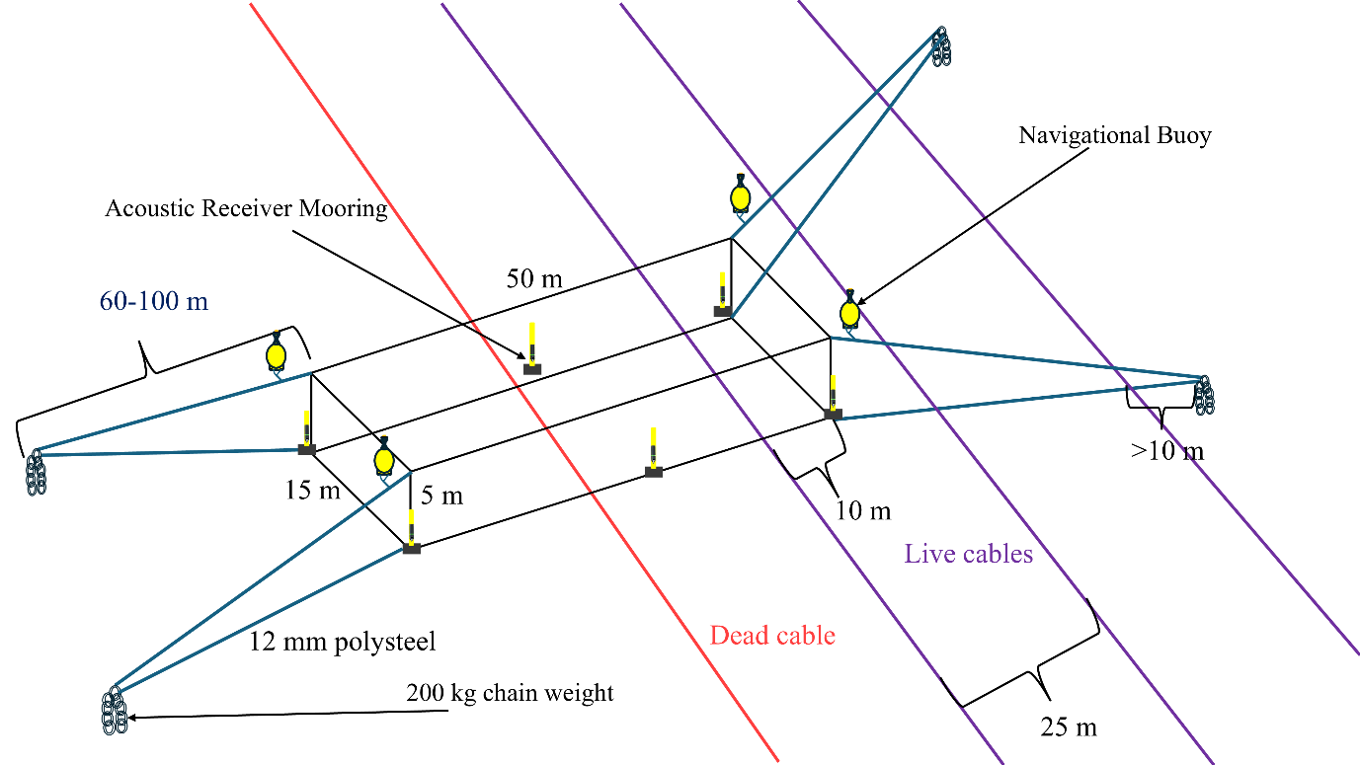
Figure 1. Overview of the enclosure, mooring system, acoustic receiver, and navigational buoys in relation to buried power transmission cables.

2.3 Receiving Environment
All equipment will be deployed above and nearby an ESB Networks managed buried power transmission cable route in Cork Harbour outside of any channels and marine traffic. The seabed in the proposed location is flat and mostly composed of coarse soft sediments with depths from 2-5.5 m depending on tidal cycle. The water column is highly turbid with elevated levels of suspended organic and inorganic matter, particularly during high winds.

3. Article 12 Assessment

3.1 Annex IV Species
In Ireland, Annex IV marine mammal species include all cetaceans, European otter (Lutra lutra), and marine turtles. The potential impact on these animals, due to our proposed maritime activity is related to vessel and enclosure operations and sound emitted by the HR2 acoustic receivers.

3.2 Impacts
The works in the maritime usage area introduces several elements that may impact Annex IV species and European sites including vessel presence, sound production, and entanglement from enclosure netting.
Potential impacts from the vessel include visual and acoustic disturbance to the environment, and the risk of collision. Considering the vessel activity levels in Cork Harbour, the temporary addition of two vessels for a period of one to two days and one vessel every 2-3 days is not significant. All vessel movement around the enclosure will be slow and deliberate, mitigating potential collision risk. Consequently, the likelihood of significant impacts on Annex IV species from vessel presence is not considered.
During the operational phase, the acoustic receivers will emit 180 kHz acoustic signals every 25-330s at 143 dB. This frequency band is above the hearing range of most fish, invertebrates, diving birds, and marine mammals, except harbour porpoise. The power is also below the intensity required to cause harm to marine mammals based on recommendations outlined in Southall et al., 2007. For these reasons, the sound produced from acoustic receivers is not likely to cause harm to Annex IV species.
The enclosure is composed of thick 40 mm nylon mesh designed to contain lesser spotted catsharks. To become entangled, an annex IV species would have to either randomly encounter the enclosure or be attracted towards it. As the enclosure is small in relation to Cork Harbour, the probability of a random encounter is low. The study species is not normally prey for annex IV species and therefore there is no attractant for predators. Assuming an encounter, the netting is static and under horizontal tension, and the mooring system will restrict enclosure movement, thereby further mitigating the risk of entanglement (Bath et al. 2023). Entanglement risk to Annex IV species is assessed as negligible.

4. Conclusion
Because of the non-invasive nature and small scale of the temporary moorings, it can be concluded that the proposed project poses negligible risk to Annex IV species and will not result in the deterioration or destruction of their breeding sites or resting places.

5. References
Bath, G.E., Price, C.A., Riley, K.L. and Morris Jr, J.A., 2023. A global review of protected species interactions with marine aquaculture. Reviews in Aquaculture, 15(4), pp.1686-1719.
Southall, B., Bowles, A. E., Ellison, W. T., Finneran, J. J., Gentry, R. L., Greene, C. R. J., Kastak, D., Ketten, D. R., Miller, J. H., Nachtigall, P. E., Richardson, W. J., Thomas, J. A., & Tyack, P. L. (2007). Marine mammal noise exposure criteria: Initial scientific recommendations. 33(4), 411–521.

