Assessment of Impact of the Maritime Usage (AIMU) Report

CABLES – Capturing elAsmobranch Behaviour in eLEctromagnetic fieldS
Sustainability Institute, University College Cork

January 2026

Contents
1. Introduction 1
2. Project Description 1
2.1 Site Location 1
2.2 Design of deployment 2
2.3 Operation 3
2.4 Retrieval 3
3. Needs and Alternatives 3
4. Planning and Development 4
4.1 Statement of Consistency with the National Maritime Planning Framework (NMPF) 4
5. Impact Assessment 4
5.1 Land and Soils 4
5.2 Water 4
5.3. Biodiversity 4
5.4 Fisheries and Aquaculture 5
5.5 Air Quality 5
5.6 Noise and Vibration 5
5.7 Landscape and Seascape 5
5.8 Traffic and Transport 5
5.9 Cultural Heritage 5
5.10 Population and Human Health 5
5.11 Major Accidents and Disasters 5
5.12 Climate 5
5.13 Waste 5
5.14 Material Assets 6
5.15 Interactions 6
6. Summary of Mitigations 6
7. Consideration and Reasoned Conclusions 6
7.1 EIA Directive (not of a class) 6
7.2 WFD Directive 6
7.3 MSFD Directive 6
8. References 8

1. Introduction
This report has been prepared to ensure MARA can fully assess all potential impacts of a proposed maritime usage. The scale and complexity of an AIMU should reflect the scale and complexity of the project. This report pertains to a scientific experiment which will track the movement of the lesser spotted catshark (Scyliorhinus canicula) within two enclosed mesocosms when exposed to the electromagnetic field from a buried high voltage cable. This includes an analysis of the likely (positive and negative) effects for the proposed maritime activities involved in the deployment, operation and retrieval of two 40 mm nylon mesh enclosures, anchoring systems, 6 HR2 acoustic receivers (per enclosure), and special marker buoys. The findings from this research will be used to inform the public, the Offshore Renewable Energy (ORE) sector and, the Irish government of the potential environmental impacts of marine high voltage cables.

2. Project Description

2.1 Site Location
The proposed location is in the northeast portion of Cork Harbour, a large natural port fed by the rivers Lee, Douglas, Owenboy, and Owennacurra (Figure 1). The harbour is composed of coarse soft sediments (Marine Institute, 2023). The proposed location satisfied four selection criteria:
- Have an existing power transmission cable.
- Calm environment compared to other sites.
- An area of limited vessel traffic.
- Shallow depths, with a maximum depth of ~6 m during high spring tide.
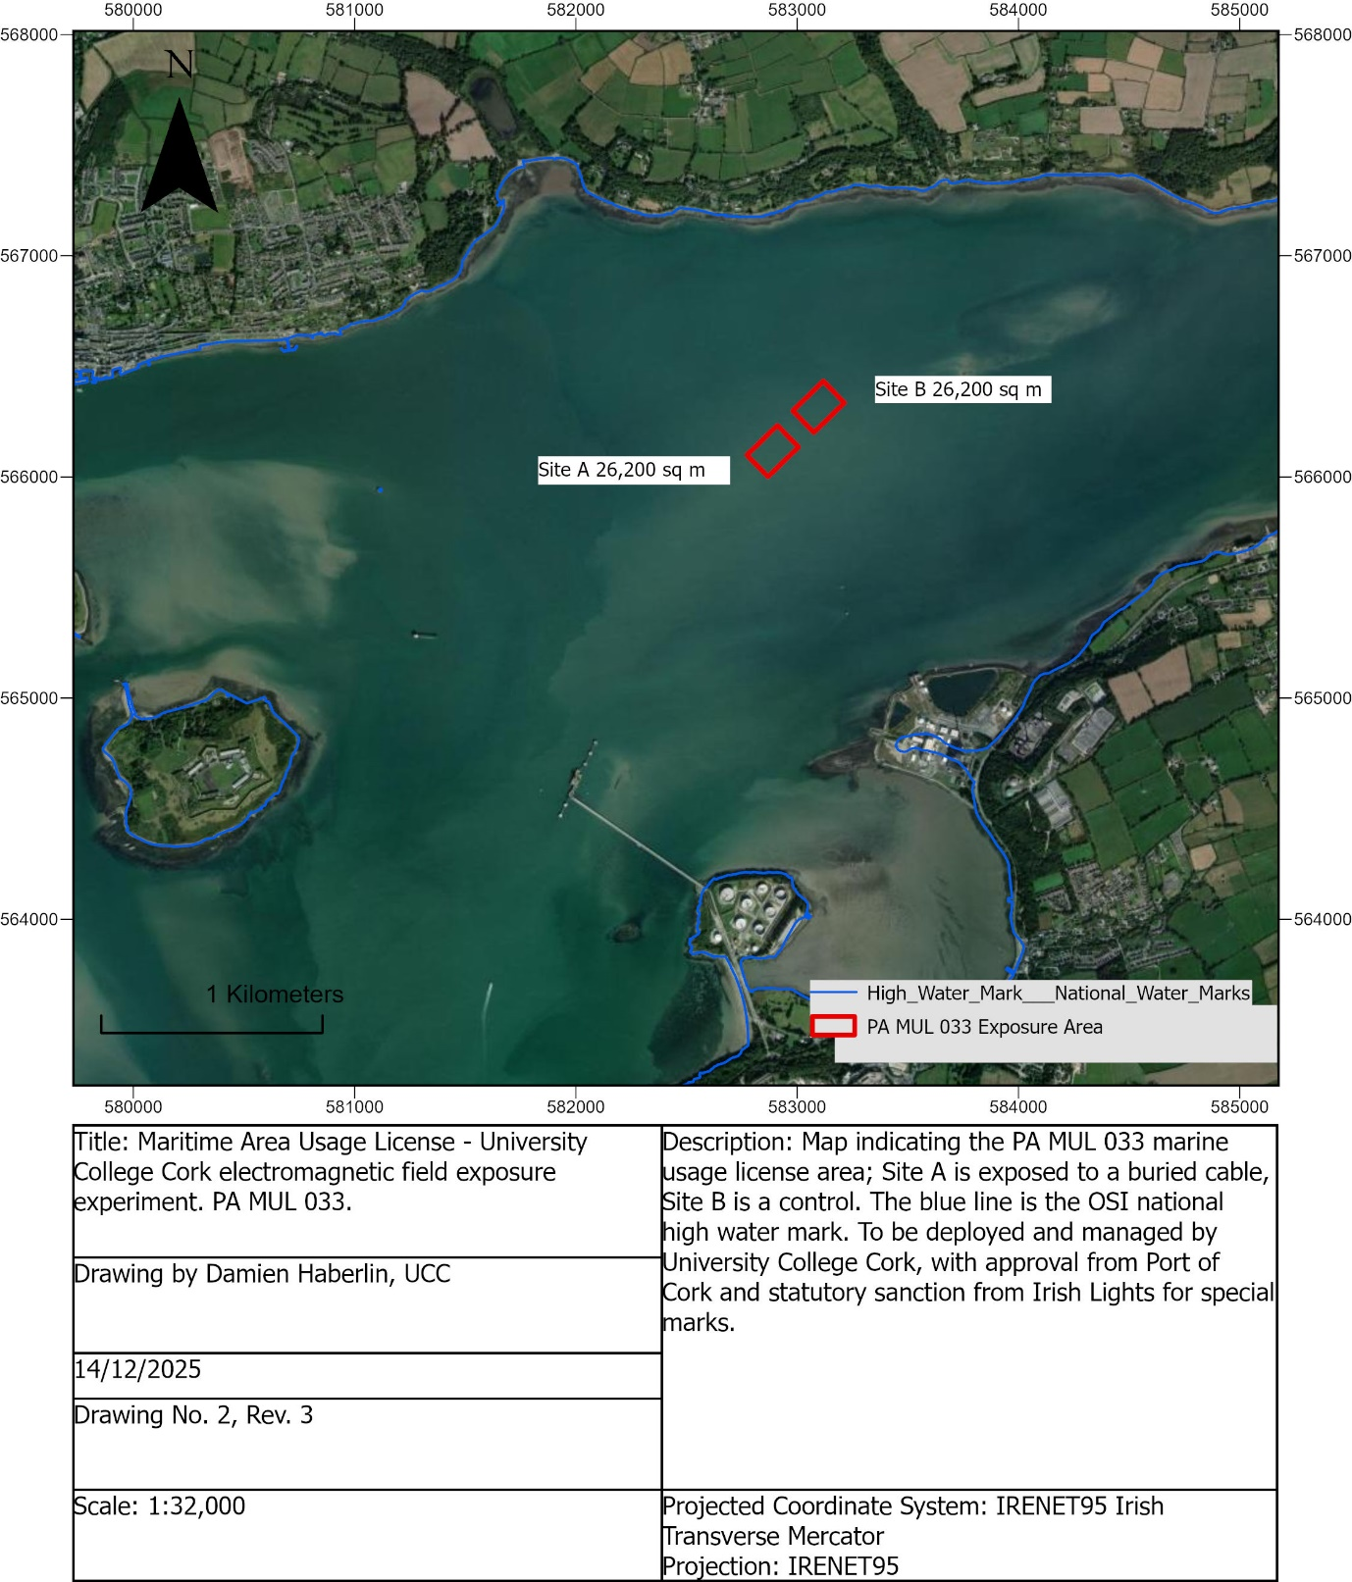
Figure 1. Site location for the proposed works in Cork Harbour, east of Spike Island and halfway between Aghada and Cuskinny Bay.

2.2 Design of deployment
The work in the proposed location requires deployment of 2 enclosures, each consisting of three pieces of equipment, the 40mm nylon mesh enclosure, the special mark buoys, and the acoustic receiver moorings. The 40 mm nylon mesh enclosure, measuring 50 m x 15 m x 5 m, is enclosed on all sides with an open top lined with seine floats. Four 200 kg scrap chains will be connected by two sets of 12 mm diameter polysteel rope to moor the enclosure in place. The enclosure will be positioned on top of the cables (Figure 1). The special mark navigational buoys will be deployed close (<5 m) to each corner of the enclosure by splicing together 12 mm polysteel from the mooring lines described above (Figure 1). Acoustic receiver moorings will be placed just outside the perimeter of the enclosure. They are composed of an ABS plastic tube embedded in an 80 kg concrete block. Figure 4 shows specific dimensions of the mooring (Figure 1).
Equipment will be deployed and retrieved from a RIB owned by MaREI and a charter vessel with a crane line hauler. All equipment will be recovered after a maximum of 2 years’ duration. Retrieval is subject to weather conditions, licensing, and vessel availability. All equipment will be removed on the same day if possible.

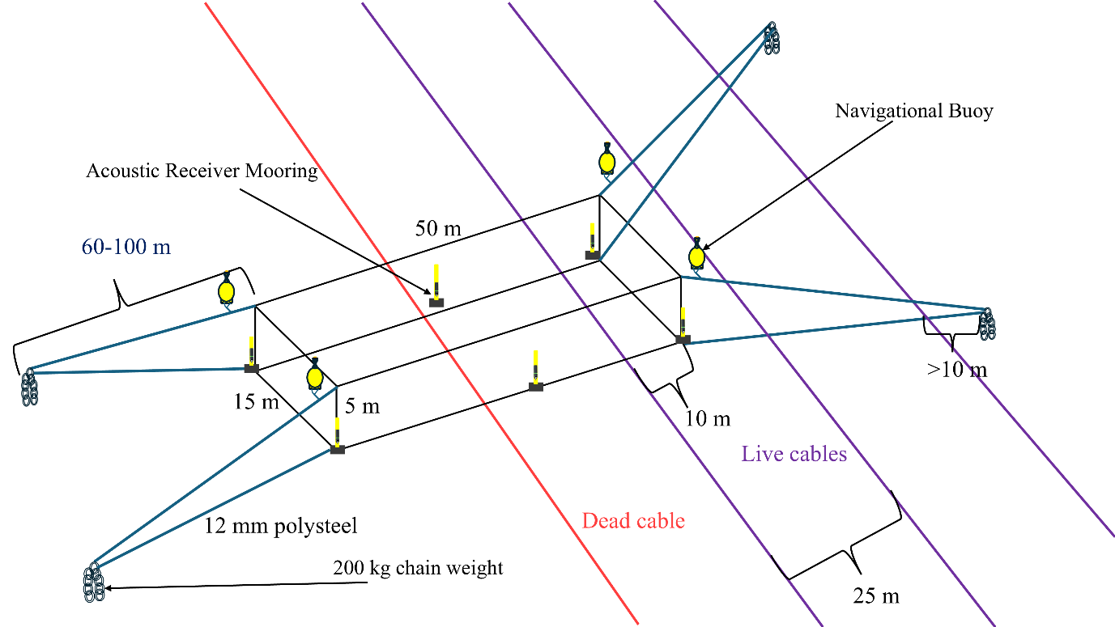
Figure 1. Overview of the enclosure, mooring system, acoustic receiver and navigational buoys in relation to buried power transmission cables.

2.3 Operation
All equipment will be in place for 12 - 24 months after deployment. The mooring system will ensure the enclosure does not move. The acoustic receivers will emit 180 kHz acoustic signals at 25-330 second intervals at 143 decibels.
The experiment operation will be as follows:
- A lesser spotted catshark will be captured <1 km from the proposed location by hook and line.
- The individual will be assessed for health upon landing.
- If the individual is not deemed healthy based on several metrics, the animal will be released.
- If the animal is healthy, it will be tagged with an external acoustic transmitter and allowed to recover within a sea pen.
- The vessel will transit to the enclosure site, and the catshark will be released into the enclosure.
- After 2-3 days, depending on weather conditions, the catshark will be recovered from the enclosure, the transmitter removed, and released after recovery.
- The process will be repeated for 30 total individuals.

2.4 Retrieval
All equipment will be retrieved in a single day, a maximum of 1 year after initial deployment, although the optimum scenario is for < 6-month deployment. The enclosure and chain weights will be recovered with a charter vessel fitted with a Hiab crane and ½ tonne hauler.

3. Needs and Alternatives
The Irish government has planned to expand offshore wind capacity to 5 GW by 2030, requiring a substantial increase in power transmission infrastructure. This infrastructure has the potential to uniquely impact vulnerable elasmobranch (sharks, rays, and skate) species by introducing anthropogenic electromagnetic fields (EMF). Elasmobranchs are threatened globally with 50% of indigenous Irish species described as vulnerable (Clarke et al., 2016). They are highly sensitive to EMF, capable of detecting and reacting to it in their environment (Kalmijn, 1971). Despite this sensitivity and vulnerability, research on how they react to power transmission cable and the associated EMF is limited to two published studies (Gill et al., 2009; Hutchison et al., 2020). Although these studies provide adequate baseline data, they face several limitations and have since not been explored further. This project aims to help fill these knowledge gaps by describing the movement of lesser spotted catsharks in relation to a buried power transmission cable.
The findings from the proposed works will be used to inform consultants and offshore wind developers on how power infrastructure may impact elasmobranchs. These findings should be considered in all following MARA applications and EIA reports related to the construction of power infrastructure in the marine environment.

4. Planning and Development

4.1 Statement of Consistency with the National Maritime Planning Framework (NMPF)
The NMPF sets out Overarching Marine Planning Policies (OMPPs) that applies to all marine activities or development including policies related to co-existence with biodiversity, coastal and island communities and infrastructure. Given the relatively small scale and temporary nature of the proposed works, there will be no impact on planning and development in the area (see attachment 4.1).

5. Impact Assessment

5.1 Land and Soils
The weights and enclosure will temporarily disturb the seabed in the immediate area where deployed. There will be loss of soft sediment habitat in the immediate area of the weights and along the bottom panel of the enclosure. Due to the temporary nature of the project and the small scale of seabed disruption, it is assessed that there will be no significant impact to land and soil in the area.

5.2 Water
Based on the works, there will be no impact on water quality in the area.

5.3. Biodiversity
The weights and enclosures will cause a temporary loss of soft sediment habitat in the immediate area of their deployment. Due to the scale of the project, it is assessed that there will be no significant impact on the biodiversity of the area.

5.4 Fisheries and Aquaculture
It is unlikely that a disturbance of commercial fisheries will occur in the area. The proposed location does not overlap with any aquaculture or fishing activities. Although there will be a temporary exclusion of fishing activity in the proposed location, the scale of the project means the area is small. Due to these reasons, it is assessed that there will be no significant impact on fishing and aquaculture in the area.

5.5 Air Quality
Based on the works, there will be no impact on air quality in the area.

5.6 Noise and Vibration
Based on the volume of traffic in Cork Harbour, the addition of two vessels to deploy, operate and retrieve experimental equipment is insignificant. For this reason, it is assessed that there will be no significant impact on noise and vibration in the area.

5.7 Landscape and Seascape
Based on the works, there will be no impact to landscape and seascape in the area.

5.8 Traffic and Transport
Based on the volume of traffic in Cork Harbour, the addition of two vessels to deploy, operate and retrieve experimental equipment is insignificant. Also, the proposed location is outside of the shipping channels. For these reasons, it is assessed that there will be no significant impact on noise and vibration in the area.

5.9 Cultural Heritage
The proposed location does not overlap with any historical wrecks and archaeological sites; therefore, it is assessed there will be no impact.

5.10 Population and Human Health
Based on the works, there will be no impact on population and human health in the area.

5.11 Major Accidents and Disasters
Although the risk of an accidental fuel spill is present, the presence of two well-maintained vessels is not considered a significant risk.

5.12 Climate
Other than indirect impacts on climate change resulting from the use of vessel fuel, there is no potential impact on climate.

5.13 Waste
Based on the works, there is no potential for impact on waste in the area.

5.14 Material Assets
Based on the works, there is no potential for impact on material assets in the area.

5.15 Interactions
Based on the works, it is assessed that there are no potential interactions to consider.

6. Summary of Mitigations
The proposed works have taken several mitigations to lessen the potential impacts to the environment, protected species, recreation, and commercial activities in the area. Lighted navigation buoys will be deployed to alert vessels of an ongoing experiment to avoid any collisions. In addition, a marine notice will be issued to all mariners for the duration of the study. The enclosure is composed of thick nylon mesh, sized to trap cat sharks and not to entangle other marine species. Lastly, the enclosure will be monitored closely throughout the experiment duration.

7. Consideration and Reasoned Conclusions

7.1 EIA Directive (not of a class)
Under the EU’s Environmental Impact Assessment (EIA) Directive (2011/92/EU as amended by 2014/52/EU), projects in the EU that may influence the environment must be subject to an EIA. Given the small-scale, temporary nature, limited impacts and mitigations listed in this document and the SISAA report, it is assessed that significant impacts are unlikely. Therefore, an EIA is not needed for the proposed works.

7.2 WFD Directive
The Water Framework Directive (WFD) has been the main law for water protection in Europe by ensuring there is enough water, free of pollution, to support wildlife and human needs. It applies to inland, transitional and coastal surface waters as well as groundwaters. The WFD pursues these goals by protecting aquatic ecology and habitats, drinking resources and bathing waters, through river basin management, planning and monitoring. Member states are required to conserve and restore these water bodies to good ecological status (GES) by 2027. Given the relatively small scale and temporary nature of the proposed works, there will not be an impact on achieving or maintaining WFD GES.

7.3 MSFD Directive
The EU Marine Strategy Framework Directive (MSFD) was put in place to protect the marine ecosystem and biodiversity upon which our health and marine-related economic and social activities depend. It enables sustainable use of marine goods and services through the management of human activities to achieve good environmental status (GES). In the directive it is stated that,” The marine environment is a precious heritage that must be protected, preserved and, where practicable, restored with the ultimate aim of maintaining biodiversity and providing diverse and dynamic oceans and seas, which are clean, healthy and productive”.
The MSFD outlines many negative impacts, for example pollution, biodiversity loss, seabed damage, overexploitation, spread of non-indigenous species, marine litter, underwater noise, and ocean warming and acidification. The MSFD also outlines 11 qualitative descriptors for EU countries to achieve GES. An analysis on how our project impacts each descriptor is found in Table 1 below.
Table 1. MSFD Analysis
Descriptor | Analysis | Assessment
Descriptor 1: Biodiversity | As concluded in sections 5 and 6, and in the SISAA and Annex IV Risk Assessment reports, no potential impacts on biodiversity are expected. | No potential for impact.
Descriptor 2: Non-indigenous species | There is no opportunity for the proposed works to introduce or spread non-indigenous species. | No potential for impact.
Descriptor 3: Population of commercial fish and shellfish species are healthy | No commercial fishing occurs in the proposed location, in part, due to the placement of buried power infrastructure. Given the scale and duration of the works, it is unlikely there will be an impact on valuable species. | No potential for impact.
Descriptor 4: Food webs ensure long-term abundance and reproduction of species | There are no elements of the project that may impact food webs or affect long-term abundance and reproduction of species. | No potential for impact.
Descriptor 5: Eutrophication is reduced | Eutrophication is not impacted by the proposed works. | No potential for impact.
Descriptor 6: Sea floor integrity ensures the proper functioning of ecosystems | Weights and the enclosure will disturb the benthic habitat in their immediate area. Given the relatively small-scale and temporary nature of this project, no potential for significant impact was identified. | No potential for impact.
Descriptor 7: Permanent alteration of hydrographical conditions does not adversely affect ecosystems | The proposed works do not have the potential to cause any hydrographical changes. | No potential for impact.
Descriptor 8: Concentrations of contaminants give no pollution effects | Vessel presence has an inherent risk of fuel spillage but is unlikely due to mitigations outlined in section 6. | No potential for significant impacts.
Descriptor 9: Contaminants in seafood are at safe levels | The proposed works do not have the potential to introduce contaminants to seafood. | No potential for impact.
Descriptor 10: Marine litter does no cause harm | All equipment will be retrieved, therefore there is no potential to introduce marine litter. | No potential for impact.
Descriptor 11: Introduction of energy (including underwater noise) does not adversely affect the ecosystem | The acoustic receivers and presence of two vessels introduce underwater noise in the proposed location and surrounding area. The acoustic receiver noise has been assessed to not impact marine life given the frequency band emitted. Given this, and the small scale of the works and level of vessel traffic in the area, no potential for significant impact was identified. | No potential for significant impact.

Based on the report’s assessment, relatively small scale and temporary nature of the project, there will not be an impact on achieving and maintaining the objectives of the MSFD.

8. References
Clarke, M., Farrell, E. D., Roche, W., Murray, T. E., Foster, S., & Marnell, F. (2016). Ireland Red List No. 11: Cartilaginous fish [sharks, skates, rays and chimaeras.
Gill, A., Huang, Y., Gloyne-Phillips, I., Metcalfe, J., Quayle, V., Spencer, J., & Wearmouth, V. (2009). COWRIE 2.0 electromagnetic fields (EMF) phase 2: emf sensitive fish response to em emissions from sub-sea electricity cables of the type used by offshore renewable energy industry (report no. COWRIE-EMF-1-06).
Hutchison, Z. L., Gill, A. B., Sigray, P., He, H., & King, J. W. (2020). Anthropogenic electromagnetic fields (EMF) influence the behaviour of bottom-dwelling marine species. Scientific Reports, 10(1). https://doi.org/10.1038/S41598-020-60793-X
Kalmijn, A. J. (1971). The electric sense of sharks and rays. Journal of Experimental Biology, 55(2), 371–383. https://doi.org/10.1242/JEB.55.2.371
Marine Institute. (2023). INFOMAR Seabed Sediment Classification.

