PUBLIC NOTICE

The Maritime Area Planning Act 2021 and the European Communities (Birds and Natural Habitats) Regulations 2011

Invitation for public submissions on an application for a maritime usage licence and an appropriate assessment

EirGrid plc submitted an application to the Maritime Area Regulatory Authority (“MARA”) for a maritime usage licence under section 117 of the Maritime Area Planning Act 2021 to undertake marine site investigation surveys in Dublin Bay from Blackrock Park to Shellybanks and Poolbeg Lighthouse. The proposed MUL is required to enable EirGrid to acquire site specific technical and environmental data to provide a reliable basis for design development, and to support the consenting and construction phases of a proposed 220kV electrical cable circuit, the CP1146 Carrickmines to Poolbeg Project, which is part of EirGrid’s Powering Up Dublin Programme.
The applicant has applied for a MUL duration of 2 years during which the surveys will be carried out on a phased basis.
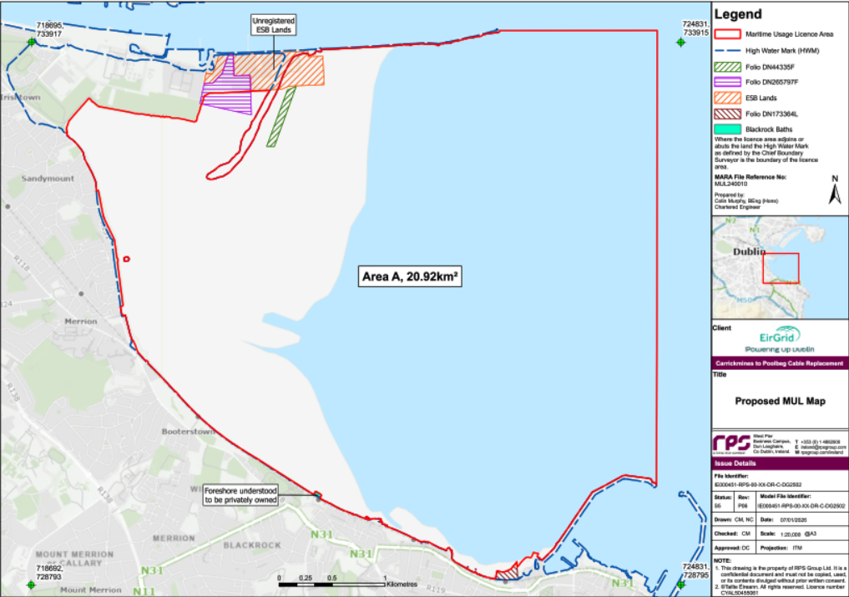

A related Natura Impact Statement has been submitted with the above licence application. The licence application and the Natura Impact Statement are available for inspection on MARA’s website www.maritimeregulator.ie/application/mul240010 and at the following address by appointment– Maritime Area Regulatory Authority, 2nd Floor, Menapia House, Drinagh Business Park, Drinagh, Wexford, Y35 RF29.
Members of the public who wish to make a submission in writing to MARA on the licence application and the Natura Impact Statement may do so quoting ref: MUL240010 to the following e-mail address – licence@mara.gov.ie or by post to the following address - Licence Unit, Maritime Area Regulatory Authority, 2nd Floor, Menapia House, Drinagh Business Park, Drinagh, Wexford, Y35 RF29.
The closing date and time for a written submission to be received by MARA is 17.30 on 22/02/2026
MARA will then, as soon as practicable, carry out the appropriate assessment determination in accordance with Regulation 42 of the European Communities (Birds and Natural Habitats) Regulations 2011. After the determination, MARA will either grant, part grant or refuse the licence application.
Dated this 22nd day of January 2026
The Maritime Area Regulatory Authority

